***DIET PLAN APP***

* **INTRODUCTION**

Nowadays maintaining diet, a healthy routine and a proper fitness track is quite difficult in this busy life, that’s why we have created an app known as ***Stay Healthy*** that would check your daily fitness track and would update you with new features and would keep a check and balance to your diet within seconds.

* **OBJECTIVES:**
* The main objective of our app is to give people a healthy lifestyle.
* To assign them diet plan according to their requirements.
* To track nutritional and to manage diet for a better lifestyle.
* Promises a good physical condition.
* RESULT OUTCOME/EXPLANATION:

The following is the explanation of our project.

* ***The login page***

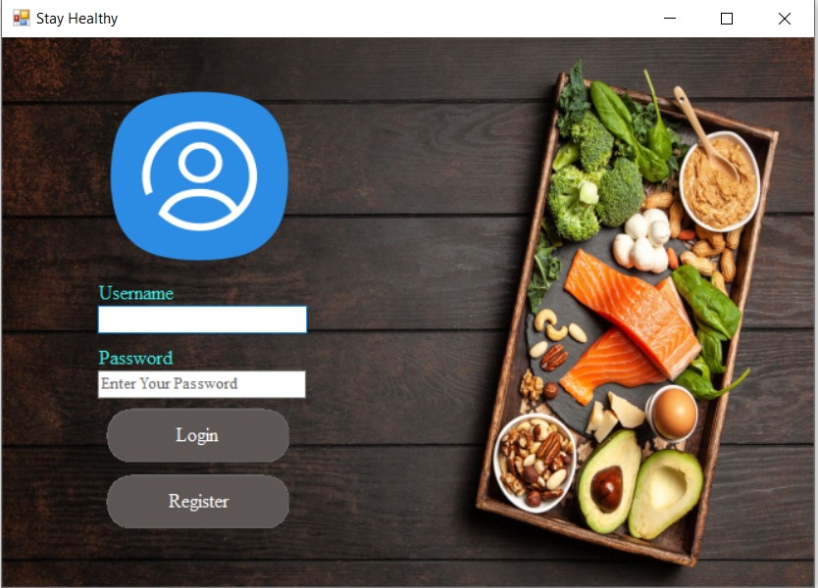

The login page is the first tab that appears on our app. It has two buttons **login** and **registration**. **Login** for those users who already have an account on this app (email or password stored in our database). **Registration** for those who doesn’t have an account in this app (their data will be stored in the database later on).

* ***Registration tab***

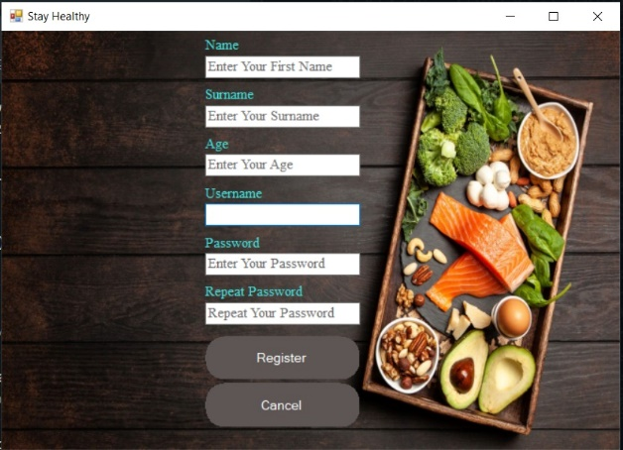

if the user clicks on the register button he would be automatically shifted to this tab

where he would register himself into this app (his information will be saved in the

database).

By clicking on register his information will be saved. Then he would go back to the login tab and sign in.

* ***Menu Tab***

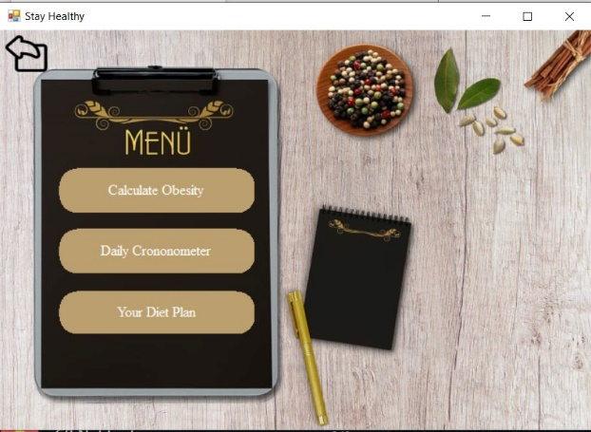

When the user will sign in he would be shifted to the menu tab where, he would be given three option to choose **calculate obesity, daily chronometer, your diet plan.** The function of calculate obesity is that it calculates obesity by putting weight and age, and it would assign table according to your obesity if you are obese than the table of **overweight** will be shown, if you are maintained than **maintenance table** will be shown and if you are under weight than **underweight** table will be shown (each with 5 days of diet plan).

* **Obesity calculator**

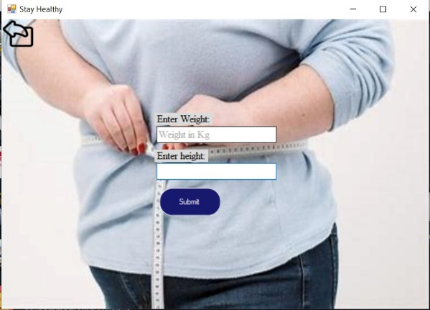

It is used to calculate the obesity of a person using the obesity formula.

* 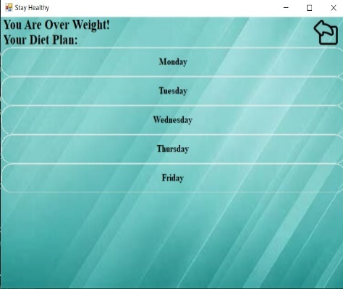**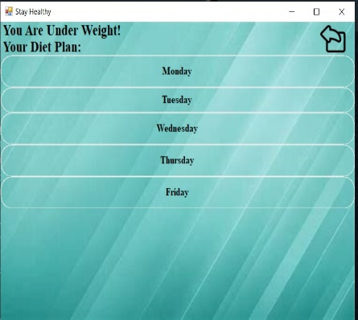the following three tables are: -**

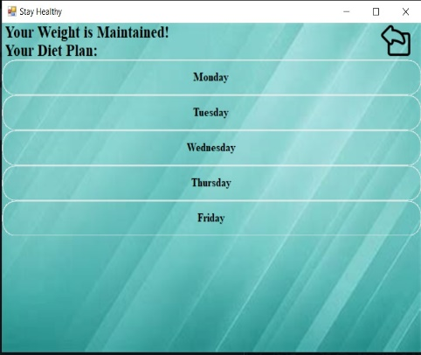

* ***The Daily Cronomometer***

It checks the total calories a person has consumed according to his diet according to the quantity.

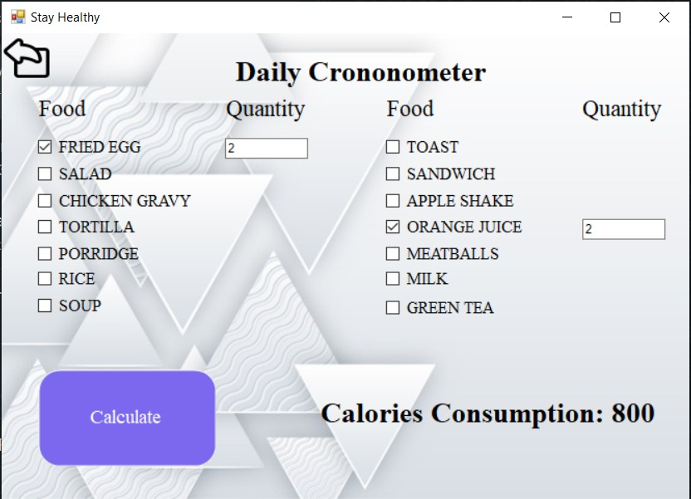

* ***Your diet plan***

It let you choose the table of your own choice by checking your obesity first. In this way you are allowed to design or create the table according to your requirements

* ***Future Scope:***

If this app proved to be beneficial than people who would follow this app might live a healthy life. more people would be aware of the healthy life style and would adopt it. A nourishing and clean environment will be set up. The more this app would spread the more it would help people achieve a nutritious and hale and hearty life.

* **CONCLUSION:**

With the help of sql server and visual studio we were successful in creating our diet plan app “Stay Healthy”. Our objectives for maintaining a healthy lifestyle for people was achieved and we were successful in creating an app which contain all the requirements for people who are conscious about their health problems and their maintenance of weight.